**PRAKTIKUM ALGORITMA DAN STRUKTUR DATA**

**TUGAS AKHIR**

**“QUICK SORT”**

**(KELAS D)**



**Oleh :**

**SYARIFATUL DAIMAHTUL FATIYYAH (L200190077)**

**MUHAMMAD NUR TAUFIQ (L200190085)**

**INFORMATIKA**

**FAKULTAS KOMUNIKASI DAN INFORMATIKA**

**UNIVERSITAS MUHAMMADIYAH SURAKARTA**

**2021**

**A. Deskripsi Tugas (Topik Quick Sort)**

Membuat Program Pengurutan Berdasarkan:

- Huruf Alphabet Dari Kolom Tempat Pertandingan

- Waktu Pertandingan Awal Ke Akhir, Dan Sebaliknya

**B. Data yang Diolah**

**Jadwal Pertandingan Piala Dunia 2018**

|  |  |  |  |
| --- | --- | --- | --- |
| **No** | **Pertandingan / Match** | **Tempat / Venue** | **Waktu / Time** |
| 1 | Russia – Saudi Arabia | Moskwa Luzhniki | 14 June 2018, 22.00 |
| 2 | Egypt – Uruguay | Yekaterinburg | 15 June 2018, 19.00 |
| 3 | Russia – Egypt | St. Petersburg | 20 June 2018, 01.00 |
| 4 | Uruguay – Saudi Arabia | Rostov-on-Don | 20 June 2018, 22.00 |
| 5 | Arab Saudi – Egypt | Vologorad | 25 June 2018, 21.00 |
| 6 | Uruguay – Russia | Samara | 25 June 2018, 21.00 |
| 7 | Portugal – Spain | Sochi | 16 June 2018, 01.00 |
| 8 | Morocco – Iran | St. Petersburg | 15 June 2018, 22.00 |
| 9 | Portugal – Morocco | Moskwa Luzhniki | 20 June 2018, 19.00 |
| 10 | Iran – Spain | Kazan | 21 June 2018, 01.00 |
| 11 | Spain – Morocco | Kaliningrad | 26 June 2018, 01.00 |
| 12 | Iran – Portugal | Saransk | 26 June 2018, 01.00 |
| 13 | France – Australia | Kazan | 16 June 2018, 17.00 |
| 14 | Peru – Denmark | Saransk | 16 June 2018, 23.00 |
| 15 | France – Peru | Yekaterinburg | 21 June 2018, 22.00 |
| 16 | Denmark – Australia | Samara | 21 June 2018, 19.00 |
| 17 | Denmark – France | Moskwa Luzhniki | 26 June 2018, 21.00 |
| 18 | Australia – Peru | Sochi | 26 June 2018, 21.00 |
| 19 | Argentina – Iceland | Moskwa Spartak | 16 June 2018, 20.00 |
| 20 | Croatia – Nigeria | Kaliningrad | 17 June 2018, 02.00 |
| 21 | Argentina – Croatia | Nizhni Novgorod | 22 June 2018, 01.00 |
| 22 | Nigeria – Iceland | Volgograd | 22 June 2018, 22.00 |
| 23 | Iceland – Croatia | Rostov-on-Don | 27 June 2018, 01.00 |
| 24 | Nigeria – Argentina | St. Petersburg | 27 June 2018, 01.00 |
| 25 | Brazil – Switzerland | Rostov-on-Don | 18 June 2018, 01.00 |
| 26 | Costa Rica – Serbia | Samara | 17 June 2018, 19.00 |
| 27 | Brazil – Costa Rica | St. Petersburg | 22 June 2018, 19.00 |
| 28 | Serbia – Switzerland | Kaliningrad | 23 June 2018, 01.00 |
| 29 | Serbia – Brazil | Moskwa Spartak | 28 June 2018, 01.00 |
| 30 | Switzerland – Costa Rica | Nizhni Novgorod | 28 June 2018, 01.00 |
| 31 | Germany – Mexico | Moskwa Luzhniki | 17 June 2018, 22.00 |
| 32 | Sweden – South Korea | Nizhni Novgorod | 18 June 2018, 19.00 |
| 33 | Germany – Sweden | Sochi | 24 June 2018, 01.00 |
| 34 | South Korea – Mexico | Rostov-on-Don | 23 June 2018, 22.00 |
| 35 | South Korea – Germany | Kazan | 27 June 2018, 21.00 |
| 36 | Mexico – Sweden | Yekaterinburg | 27 June 2018, 21.00 |
| 37 | Belgium – Panama | Sochi | 18 June 2018, 22.00 |
| 38 | Tunisia – England | Volovograd | 19 June 2018, 01.00 |
| 39 | Belgium – Tunisia | Moskwa Spartak | 23 June 2018, 19.00 |
| 40 | England – Panama | Nizhni Novgorod | 24 June 2018, 19.00 |
| 41 | England – Belgium | Kaliningrad | 29 June 2018, 01.00 |
| 42 | Poland – Senegal | Moskwa Spartak | 19 June 2018, 22.00 |
| 43 | Colombia – Japan | Saransk | 19 June 2018, 19.00 |
| 44 | Japan – Senegal | Yekaterinburg | 24 June 2018, 22.00 |
| 45 | Poland – Colombia | Kazan | 25 June 2018, 01.00 |
| 46 | Japan – Poland | Volgograd | 28 June 2018, 21.00 |
| 47 | Senegal – Colombia | Samara | 28 June 2018, 21.00 |

**C. Hasil Olah Data**

1. File Excel .xlsx yang Berisi Data Diatas

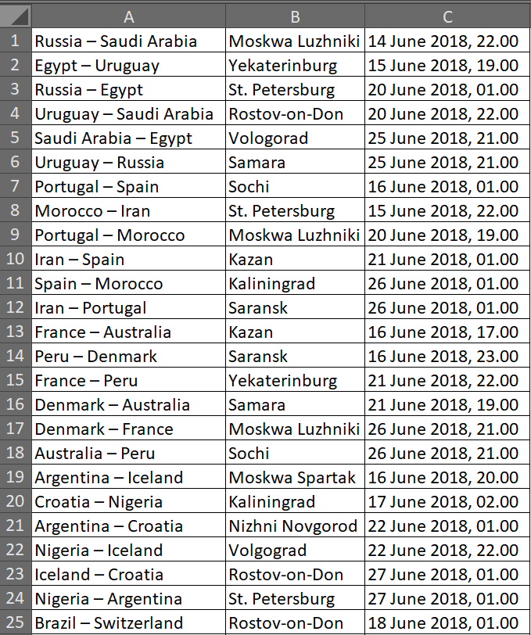

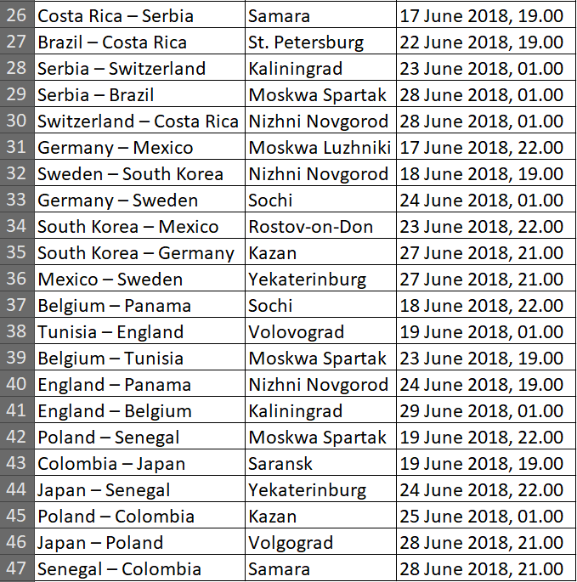

2. Import File Excel Ke Dalam Python

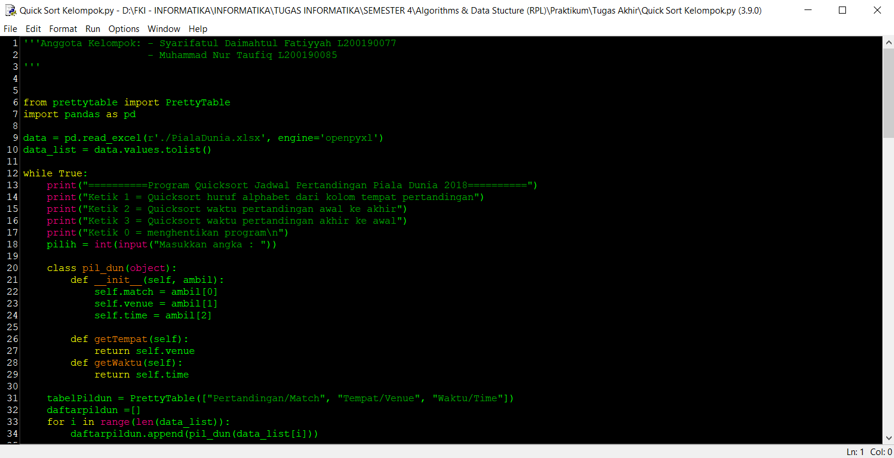

3. Program QuickSort Huruf Alphabet Dari Kolom Tempat Pertandingan

*Code*

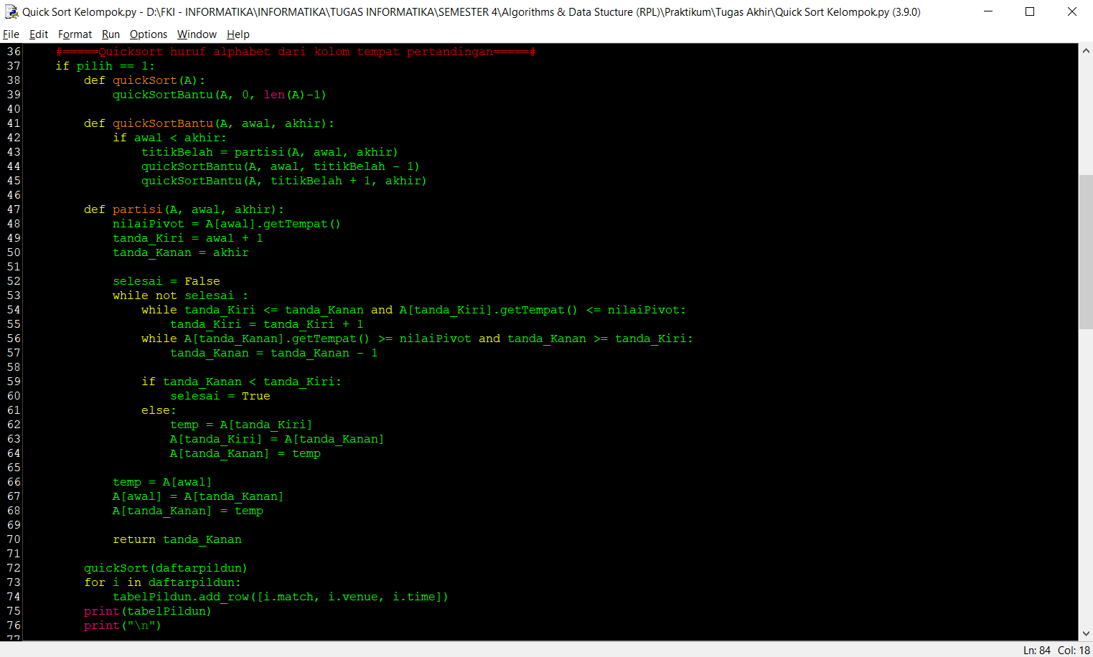

*Output*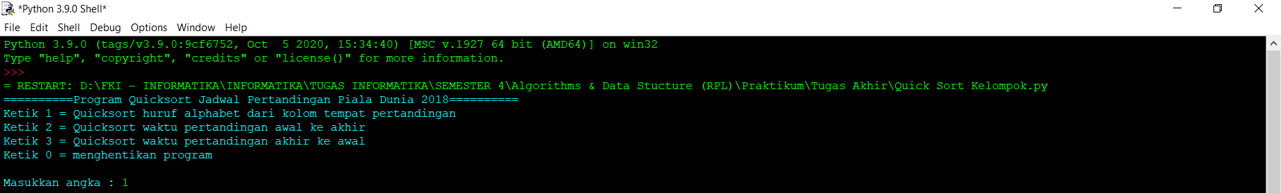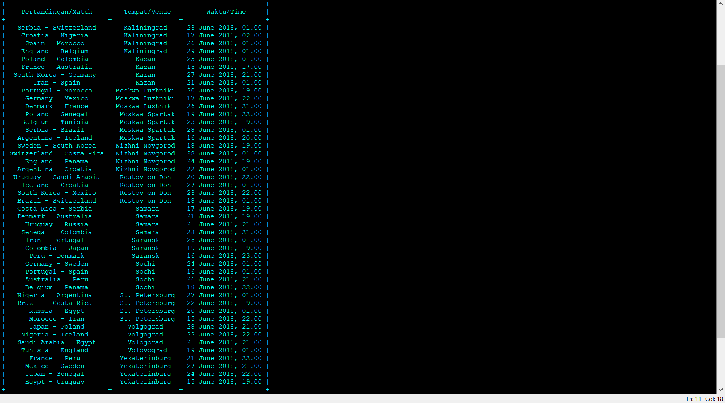

4. Program Quicksort Waktu Pertandingan Awal Ke Akhir

*Code*

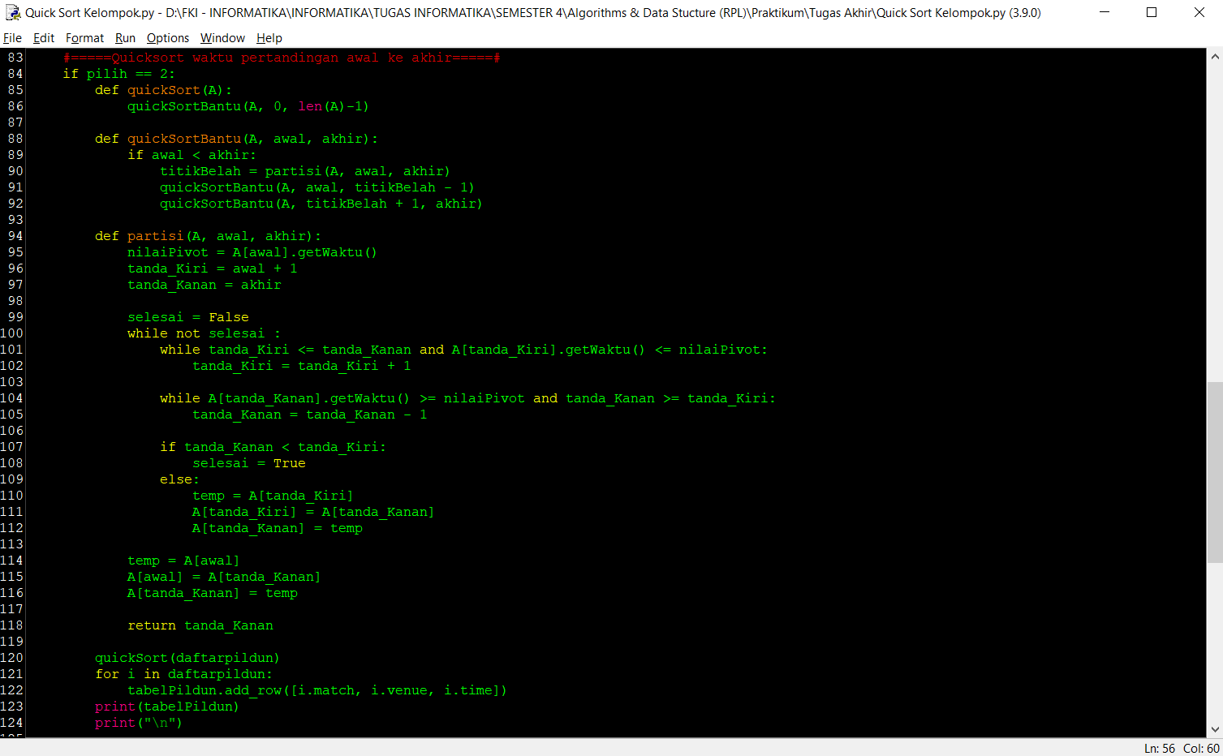

*Output*

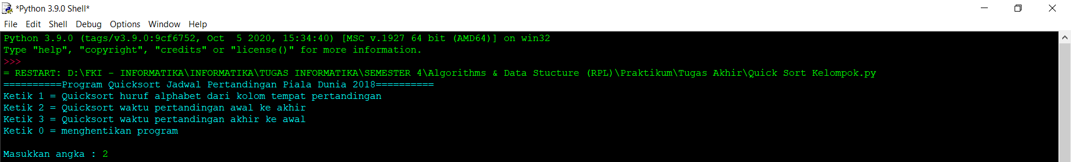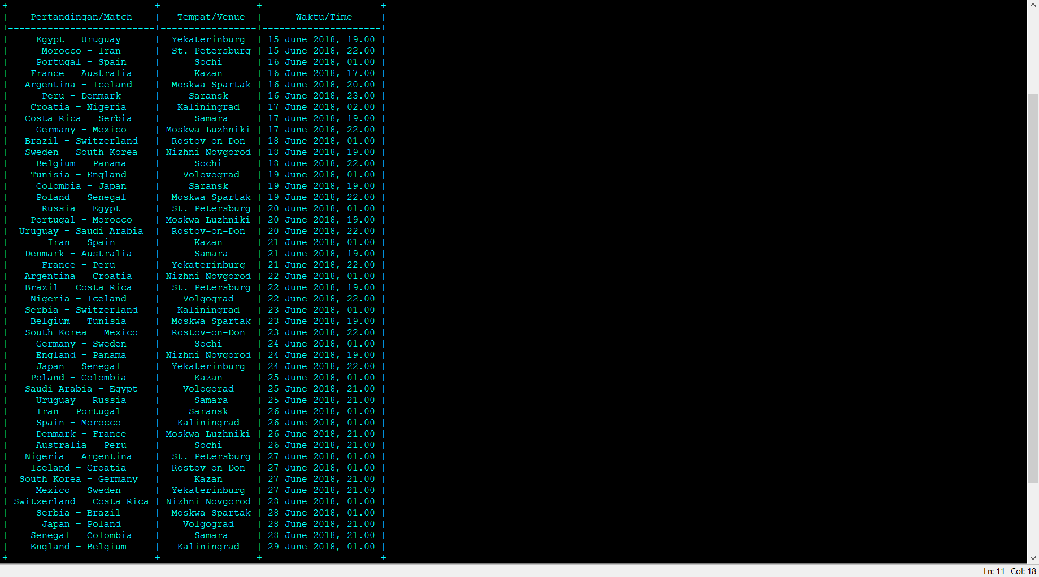

5. Program Quicksort Waktu Pertandingan Akhir Ke Awal

*Code*

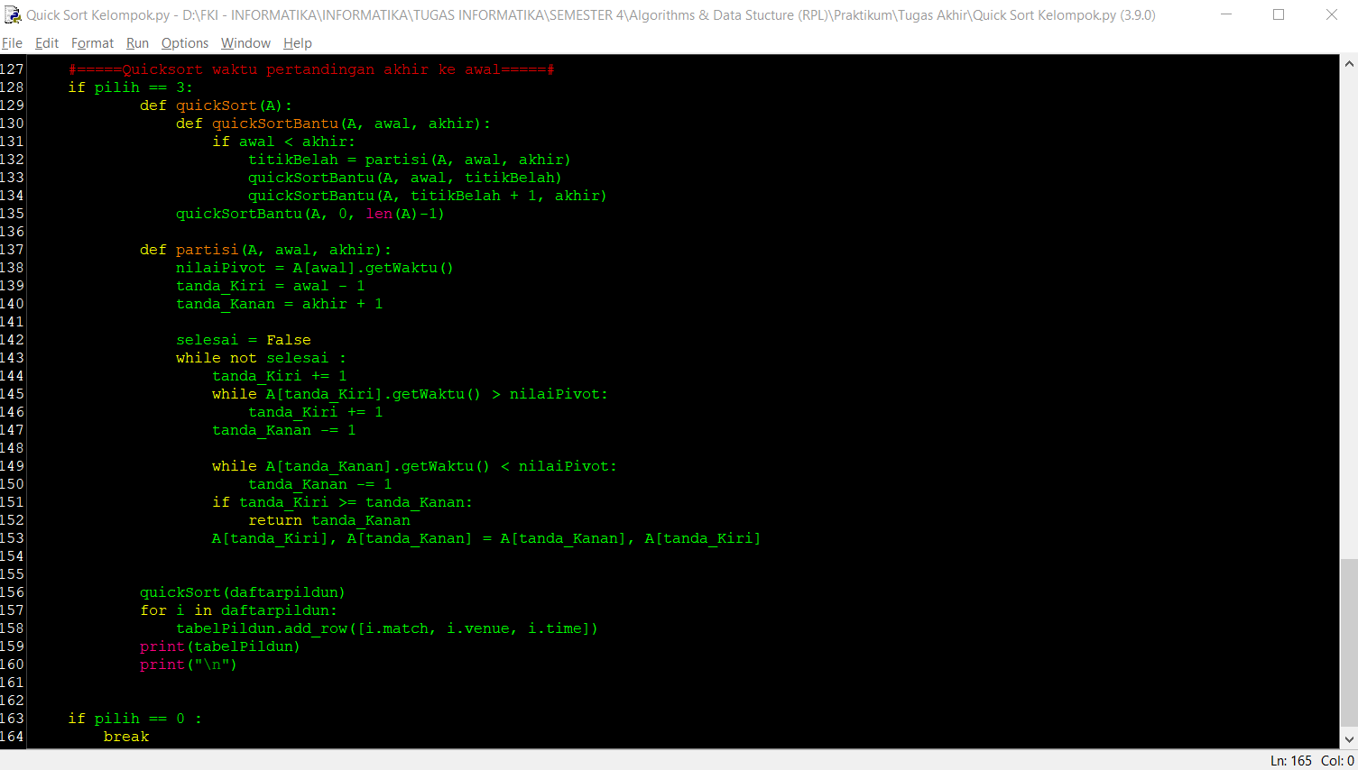

*Output*

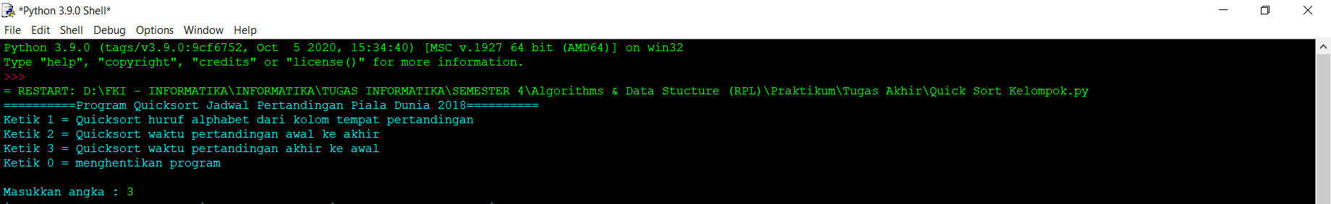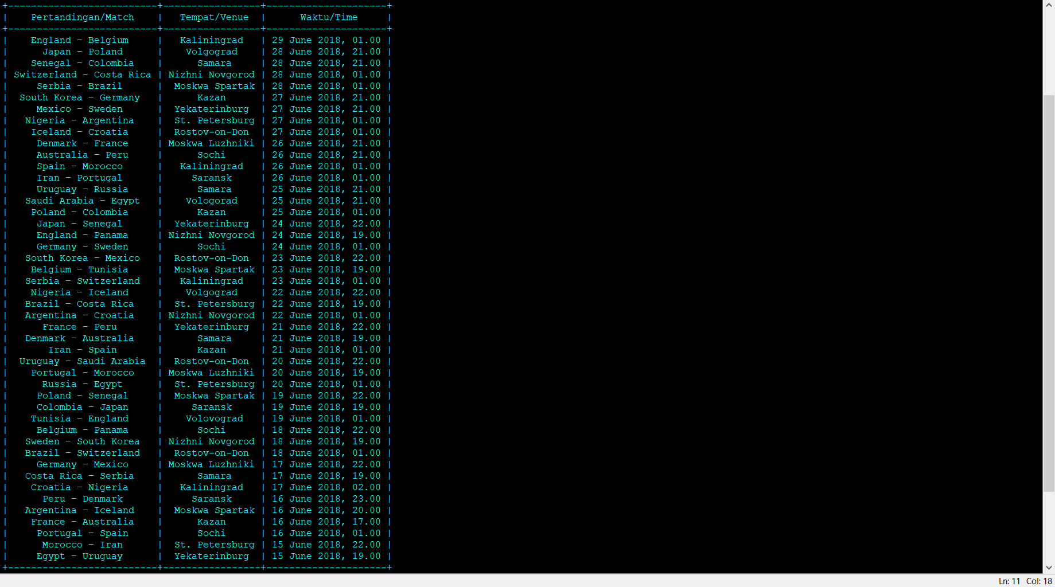

6. Menghentikan Program

